Equatorial radius
# Source: AI Source: Provided by: [Data Path: Persons Table -> ID Column: 1, Name_En Column: Motasem Essam] -> From: [ChatGPT] on [7/25/2026]
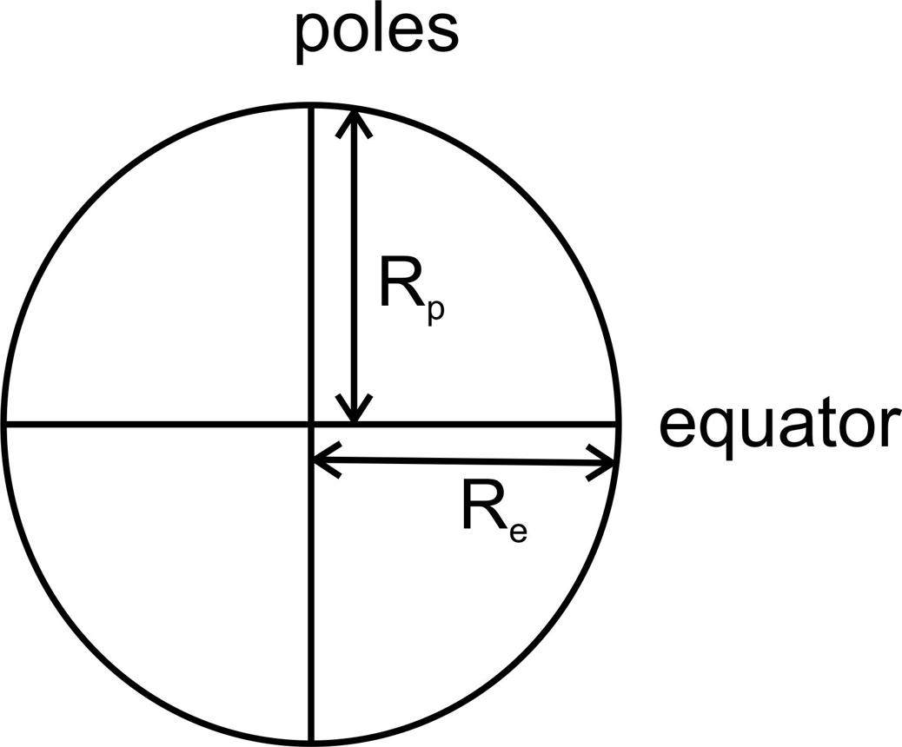
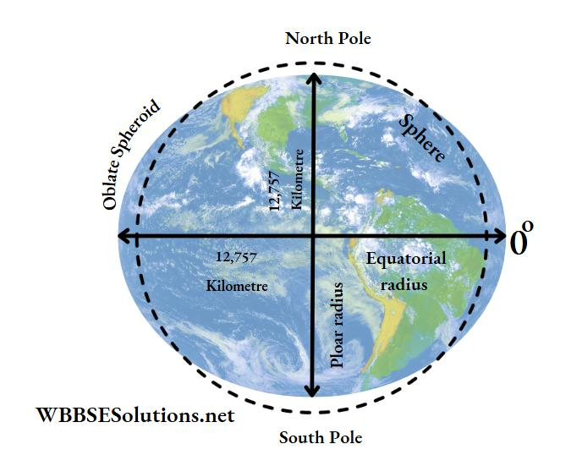
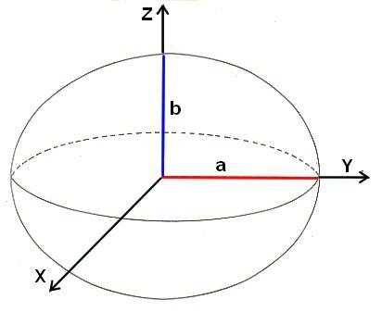

Definition
# Source: AI Source: Provided by: [Data Path: Persons Table -> ID Column: 1, Name_En Column: Motasem Essam] -> From: [ChatGPT] on [7/25/2026]
The equatorial radius is the distance from the center of a sphere-like body to a point on its equator, measured in a direction perpendicular to its polar axis.
For a perfect sphere, the equatorial radius equals the polar radius because every radius has the same length.
For an oblate spheroid, such as Earth, the equatorial radius is greater than the polar radius because the body is wider around its equator than it is tall along its polar axis.

Simple Definition
# Source: AI Source: Provided by: [Data Path: Persons Table -> ID Column: 1, Name_En Column: Motasem Essam] -> From: [ChatGPT] on [7/25/2026]
The equatorial radius is the distance from the center of a sphere or spheroid to its equator.
- Starting point: The center of the body.
- Ending point: A point on the equator.
- Direction: Perpendicular to the polar axis.
- Symbol: $R_{e}$.
- Length: Equal to the ordinary radius for a perfect sphere.

Geometric Representation
# Source: AI Source: Provided by: [Data Path: Persons Table -> ID Column: 1, Name_En Column: Motasem Essam] -> From: [ChatGPT] on [7/25/2026]
Let $O$ be the center of a sphere-like body, and let $E$ be a point on its equator.
The segment $\overline{OE}$ represents an equatorial radius:
$$\overline{OE}=\text{equatorial radius}$$
Its length is denoted by $R_{e}$:
$$OE=R_{e}$$
For an axisymmetric body, every radius from the center to the equatorial circle has the same length.

Types and Geometric Cases
# Source: AI Source: Provided by: [Data Path: Persons Table -> ID Column: 1, Name_En Column: Motasem Essam] -> From: [ChatGPT] on [7/25/2026]

Equatorial Radius of a Sphere
# Source: AI Source: Provided by: [Data Path: Persons Table -> ID Column: 1, Name_En Column: Motasem Essam] -> From: [ChatGPT] on [7/25/2026]
In a perfect sphere, the equatorial radius is equal to the polar radius and every other radius.
$$R_{e}=R_{p}=R$$
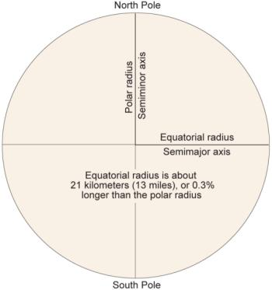

Equatorial Radius of an Oblate Spheroid
# Source: AI Source: Provided by: [Data Path: Persons Table -> ID Column: 1, Name_En Column: Motasem Essam] -> From: [ChatGPT] on [7/25/2026]
An oblate spheroid is flattened at its poles and wider around its equator.
$$R_{e}>R_{p}$$
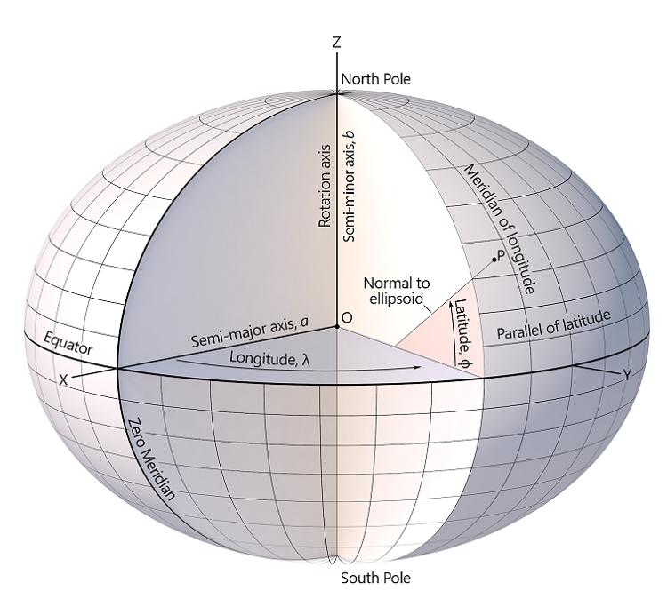

Equatorial Radius of a Prolate Spheroid
# Source: AI Source: Provided by: [Data Path: Persons Table -> ID Column: 1, Name_En Column: Motasem Essam] -> From: [ChatGPT] on [7/25/2026]
A prolate spheroid is elongated along its polar axis, making its equatorial radius shorter than its polar radius.
$$R_{e}<R_{p}$$

Key Characteristics
# Source: AI Source: Provided by: [Data Path: Persons Table -> ID Column: 1, Name_En Column: Motasem Essam] -> From: [ChatGPT] on [7/25/2026]
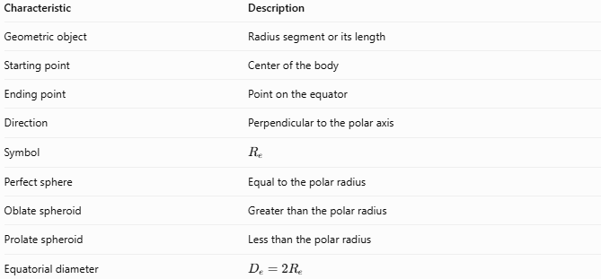
Characteristic | Description
Geometric object | Radius segment or its length
Starting point | Center of the body
Ending point | Point on the equator
Direction | Perpendicular to the polar axis
Symbol | $$R_{e}$$
Perfect sphere | Equal to the polar radius
Oblate spheroid | Greater than the polar radius
Prolate spheroid | Less than the polar radius
Equatorial diameter | $$D_{e}=2R_{e}$$

Mathematical Formulas

Equatorial Radius of a Perfect Sphere
# Source: AI Source: Provided by: [Data Path: Persons Table -> ID Column: 1, Name_En Column: Motasem Essam] -> From: [ChatGPT] on [7/25/2026]
For a perfect sphere:
$$\boxed{R_{e}=R}$$
where $R$ is the sphere's ordinary radius.

Equatorial Diameter
# Source: AI Source: Provided by: [Data Path: Persons Table -> ID Column: 1, Name_En Column: Motasem Essam] -> From: [ChatGPT] on [7/25/2026]
The equatorial diameter passes through the center and joins opposite points on the equator.
$$\boxed{D_{e}=2R_{e}}$$
Therefore:
$$\boxed{R_{e}=\frac{D_{e}}{2}}$$

Flattening of an Oblate Spheroid
# Source: AI Source: Provided by: [Data Path: Persons Table -> ID Column: 1, Name_En Column: Motasem Essam] -> From: [ChatGPT] on [7/25/2026]
The flattening factor compares the equatorial and polar radii:
$$\boxed{f=\frac{R_{e}-R_{p}}{R_{e}}}$$
where:
- $R_{e}$ is the equatorial radius.
- $R_{p}$ is the polar radius.
- $f$ is the flattening factor.
For an oblate spheroid, $f>0$. For a perfect sphere, $f=0$.

Equation of an Axis-Aligned Spheroid
# Source: AI Source: Provided by: [Data Path: Persons Table -> ID Column: 1, Name_En Column: Motasem Essam] -> From: [ChatGPT] on [7/25/2026]
For a spheroid centered at the origin, with the polar axis along the $z$-axis:
$$\boxed{\frac{x^{2}+y^{2}}{R_{e}^{2}}+\frac{z^{2}}{R_{p}^{2}}=1}$$
The equatorial radius determines the size of the cross-section in the $xy$-plane at $z=0$.

Worked Examples
# Source: AI Source: Provided by: [Data Path: Persons Table -> ID Column: 1, Name_En Column: Motasem Essam] -> From: [ChatGPT] on [7/25/2026]
Example 1 — Finding the Equatorial Radius
A perfect sphere has a diameter of $20\text{ cm}$. Find its equatorial radius.
Solution:
$$R_{e}=\frac{D_{e}}{2}$$
$$R_{e}=\frac{20}{2}$$
$$\boxed{R_{e}=10\text{ cm}}$$
Because the body is a perfect sphere, its polar radius is also $10\text{ cm}$.
Example 2 — Comparing the Radii of a Spheroid
A spheroid has an equatorial radius of $12\text{ m}$ and a polar radius of $11\text{ m}$. Identify its shape.
Solution:
$$R_{e}=12\text{ m}, R_{p}=11\text{ m}$$
Since $R_{e}>R_{p}$, the body is flattened at its poles.
Answer: It is an oblate spheroid.
Example 3 — Calculating Flattening
A spheroid has an equatorial radius of $10\text{ km}$ and a polar radius of $9.9\text{ km}$. Calculate its flattening factor.
Solution:
$$f=\frac{R_{e}-R_{p}}{R_{e}}$$
$$f=\frac{10-9.9}{10}=\frac{0.1}{10}$$
$$\boxed{f=0.01=1\%}$$
The spheroid's polar radius is 1% smaller than its equatorial radius.

Equatorial Radius vs. Polar Radius
# Source: AI Source: Provided by: [Data Path: Persons Table -> ID Column: 1, Name_En Column: Motasem Essam] -> From: [ChatGPT] on [7/25/2026]
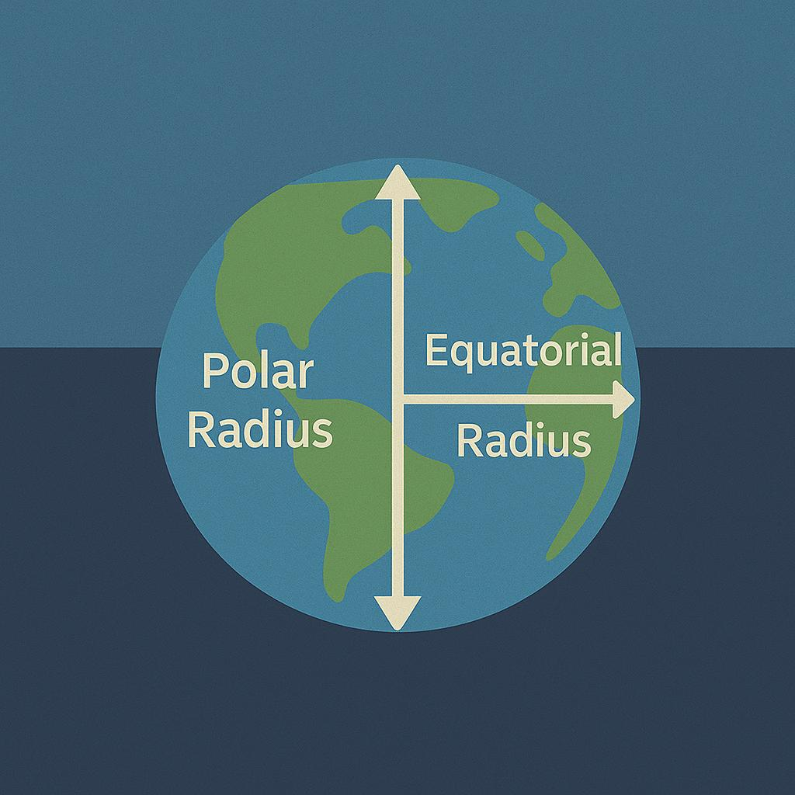
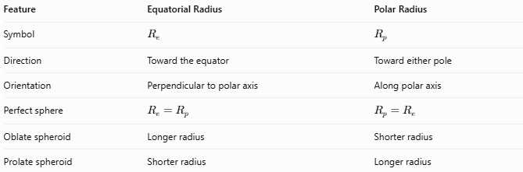
Feature | Equatorial Radius | Polar Radius
Symbol | $$R_{e}$$ | $$R_{p}$$
Direction | Toward the equator | Toward either pole
Orientation | Perpendicular to polar axis | Along polar axis
Perfect sphere | $$R_{e}=R_{p}$$ | $$R_{p}=R_{e}$$
Oblate spheroid | Longer radius | Shorter radius
Prolate spheroid | Shorter radius | Longer radius

Real-World Application: Earth
# Source: AI Source: Provided by: [Data Path: Persons Table -> ID Column: 1, Name_En Column: Motasem Essam] -> From: [ChatGPT] on [7/25/2026]
Earth is approximately an oblate spheroid. Using the WGS 84 reference ellipsoid:
- Equatorial radius: $6,378.137\text{ km}$
- Polar radius: approximately $6,356.752\text{ km}$
- Difference: approximately $21.385\text{ km}$
The equatorial radius is important in geodesy, cartography, satellite navigation, and calculations involving Earth's shape.

Key Points
# Source: AI Source: Provided by: [Data Path: Persons Table -> ID Column: 1, Name_En Column: Motasem Essam] -> From: [ChatGPT] on [7/25/2026]
- The equatorial radius extends from the center to the equator.
- It is perpendicular to the polar axis.
- In a perfect sphere, all radii are equal.
- In an oblate spheroid, the equatorial radius is greater than the polar radius.
- In a prolate spheroid, the equatorial radius is less than the polar radius.
- The equatorial diameter is twice the equatorial radius.

Conclusion
# Source: AI Source: Provided by: [Data Path: Persons Table -> ID Column: 1, Name_En Column: Motasem Essam] -> From: [ChatGPT] on [7/25/2026]
The equatorial radius measures the distance from the center of a sphere-like body to its equator. It equals the ordinary radius of a perfect sphere, but it differs from the polar radius in spheroids. This measurement is especially useful for describing and modeling planets such as Earth.

